CSA1708-ARTIFICIAL INTELLIGENCE
LAB EXPERIMENTS
Program 10 : Python Program to Implement A* Algorithm
Aim
To develop a Python program to implement the A* (A-Star) search algorithm to find the optimal shortest path between a start node and a goal node using heuristic estimation.
Algorithm
1. Define the weighted graph with edge costs g(n) and heuristic estimations h(n) representing the estimated cost from node n to the goal.
2. Initialize an open list (priority queue) containing the start node with priority f(start) = g(start) + h(start) = 0 + h(start).
3. Initialize a dictionary g_score to store the shortest distance found so far from start to each node, initialized to infinity for all nodes except g_score[start] = 0.
4. While the open list is not empty:
5. a. Pop the node current having the lowest f(n) value.
6. b. If current is the goal node, reconstruct the optimal path and return it along with total cost g_score[goal].
7. c. For each neighbor and edge cost of current:
8. i. Calculate tentative_g = g_score[current] + cost.
9. ii. If tentative_g < g_score[neighbor]:
10. - Update g_score[neighbor] = tentative_g.
11. - Calculate f_score = tentative_g + h(neighbor).
12. - Enqueue (f_score, tentative_g, neighbor, path + [neighbor]) into the open list.
13. If the open list becomes empty without reaching the goal, report that no path exists.
14. Display the optimal path from start to goal and the total path cost.

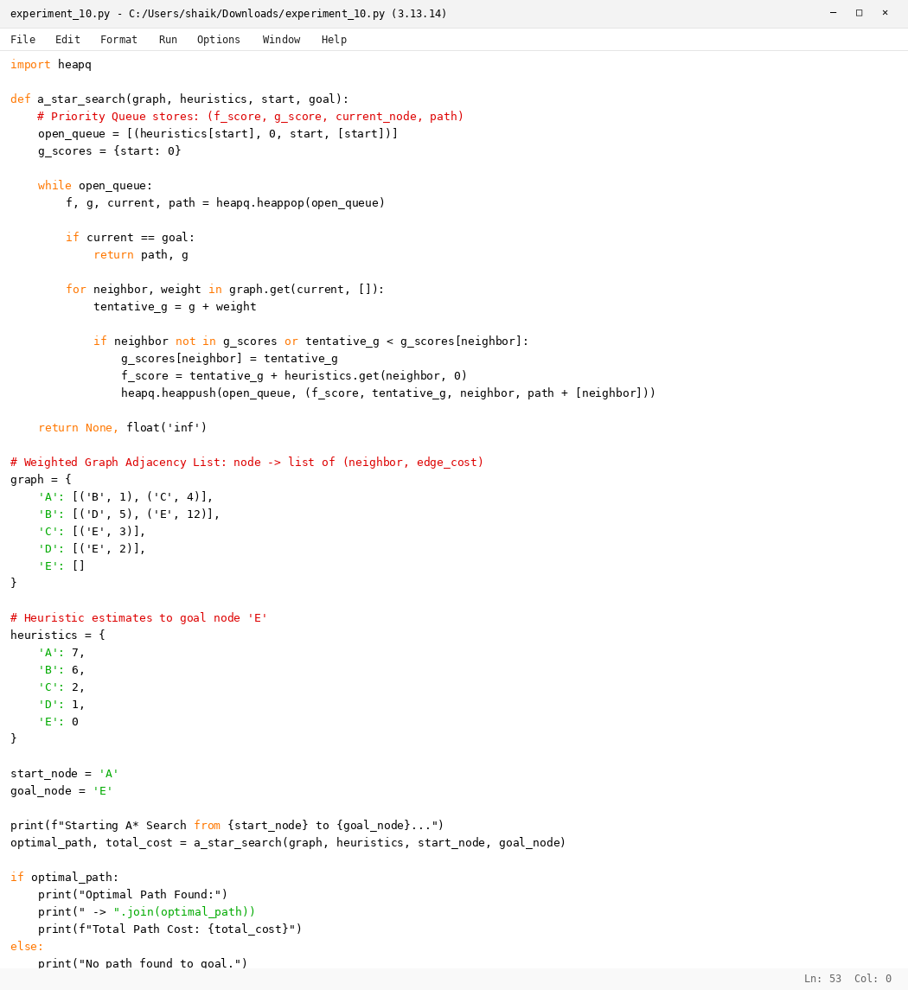

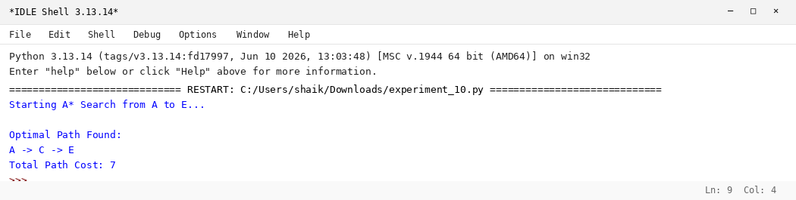

RESULT
Thus, the A* algorithm was implemented successfully using Python.

